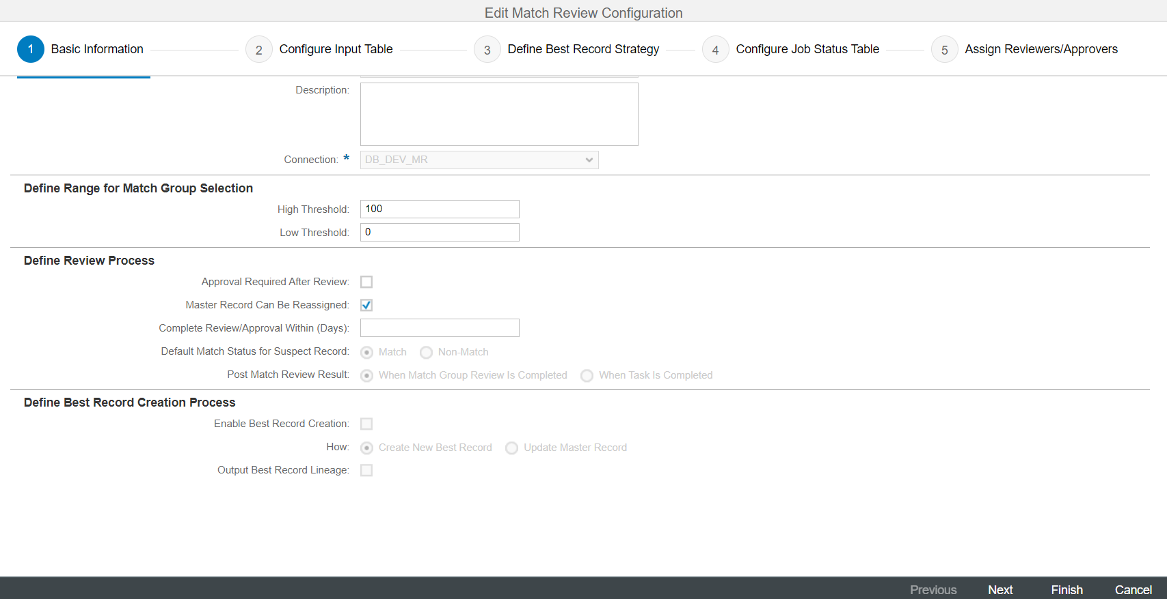

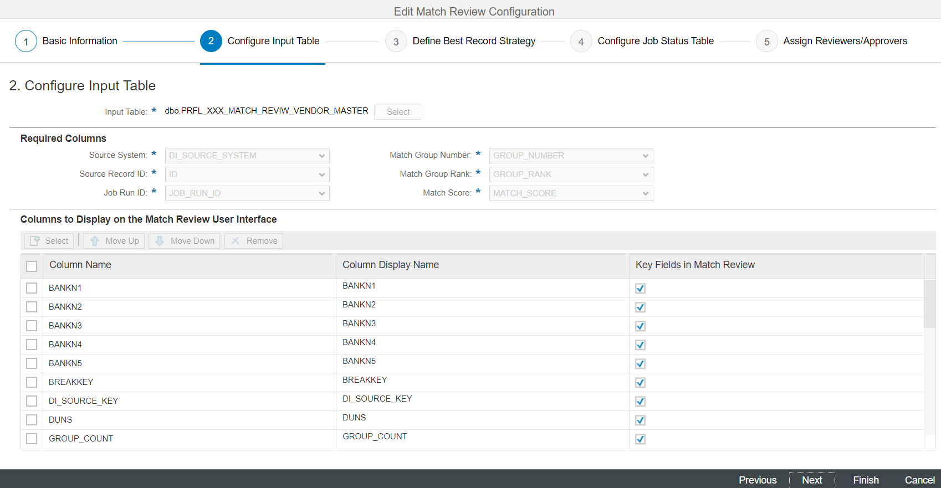

PRFL_XXX_VENDOR_MASTER_MATCH_REVIEW_OP(DS_STAGING.DBO)

PRFL_XXX_MR_JOB_STATUS_VENDOR_MASTER(DS_STAGING.DBO)

PRFL_XXX_MATCH_REVIEW_VENDOR_MASTER(DS_STAGING.DBO)

unmatch - status U

M,S

